CSS MR valdiationsBeforeInvoicing
1. Executive Summary
This SuiteScript 2.1 Map/Reduce validates Custom Invoice Records (CIR) against their Sales Orders (SO) and marks each CIR as Invoiceable only when:
- the SO contains the same Item,
- the SO line quantity (summed across identical items) is ≥ the summed CIR quantity for that (SO, Item) group, and
- the Customer on the CIR matches the SO Customer.
Validated CIRs get custrecord_is_invoiceable = T; others are set to F. This prevents over-billing and data mismatches upstream of invoicing.

2. Business Context
Operations needed a reliable gate to ensure only legitimate, correctly-quantified invoice candidates proceed. Manual cross-checks between custom records and SOs were slow and error-prone. Automating this check reduces revenue leakage (over/under billing), avoids downstream reversals, and standardizes compliance.

3. Solution Overview
A single Map/Reduce script performs:
- Intake & Grouping: Pull all active CIRs; group by (Sales Order + Item) and sum CIR qty.
- SO Snapshot: Search only those SOs; build a (SO, Item) → SO Qty map and an (SO → Customer) map.
- Validation: For each group, require item exists on SO, SO Qty ≥ Sum(CIR Qty), and CIR Customer = SO Customer.
- Writeback: Emit {cirId, isValid} to map(), which updates each CIR checkbox.
4. Functional Flow
- Read CIRs (isinactive=F) with fields: SO, Item, Qty, Customer.
- Group by (SO||Item); sum CIR qty per group; collect unique SO IDs.
- Read SO lines for those SO IDs (exclude mainline/tax/shipping) → build:
  - soItemQtyMap[SO||Item] = Σ SO line qty
  - soCustomerMap[SO] = Customer
- Validate each group: existsOnSO && (soQty ≥ sumCirQty) && (CIR customer == SO customer).
- Prepare final array of {cirId, isValid}.
- Map stage: submitFields() sets custrecord_is_invoiceable accordingly.

5. Script Details
5.1 Map/Reduce Script (CIR Validation)
Technology: SuiteScript 2.1 Map/Reduce (N/search, N/record, N/log)

Key Fields (CIR):
- custrecord_sales_order (SO)
- custrecord_invoice_item (Item)
- custrecord_inv_qty (CIR Qty)
- custrecord_cust_inv_customer (CIR Customer)
- custrecord_is_invoiceable (Output flag)
Core Structures & Helpers
- keyFor(soId,itemId) -> "SO||Item"
- getAllResults(sr) for full pagination
- safeNumber(v) to normalize numeric reads
SO Search Filters
- internalid anyof soIds, mainline=F, taxline=F, shipping=F
SO Columns
- internalid, item, quantity, entity (Customer)
Resilience
- Handles missing SO/Item gracefully (group fails closed).
- Sums duplicate SO lines for the same item.
- Logs entity mismatches across SO lines (shouldn’t occur on standard SOs).

6. Testing & Validation
Scope: Sandbox execution on representative data covering pass/fail and edge conditions.
Test Cases
- Pass: SO has Item; SO Qty ≥ Σ CIR Qty; Customers match.
- Fail — Qty: SO Qty < Σ CIR Qty.
- Fail — Item Missing: (SO, Item) not present on SO lines.
- Fail — Customer Mismatch: CIR customer ≠ SO customer.
- Fail — Missing Data: CIR missing SO/Item/Customer (group fails closed).
What to Verify
- custrecord_is_invoiceable set correctly per CIR.
- No Map errors; logs show group keys, sums, and updates.
- Spot-check SO lines to confirm summed quantities and entity equality.

Screenshots
Sales Order-49
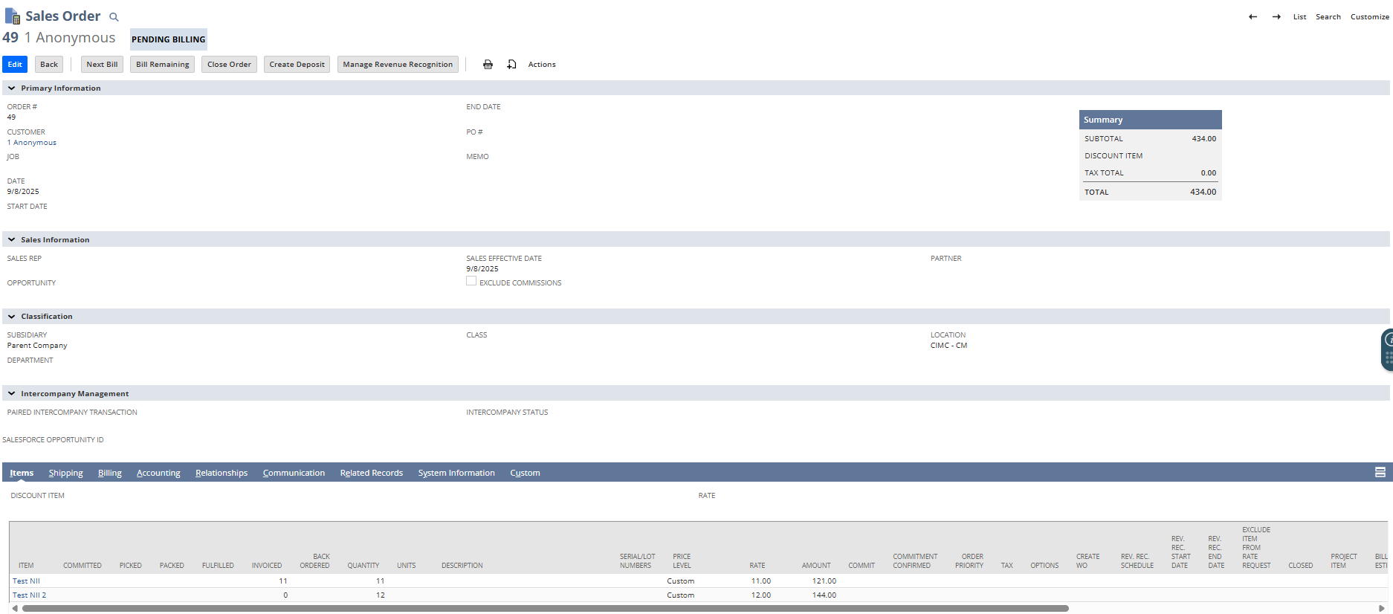

Custom Invoice-6
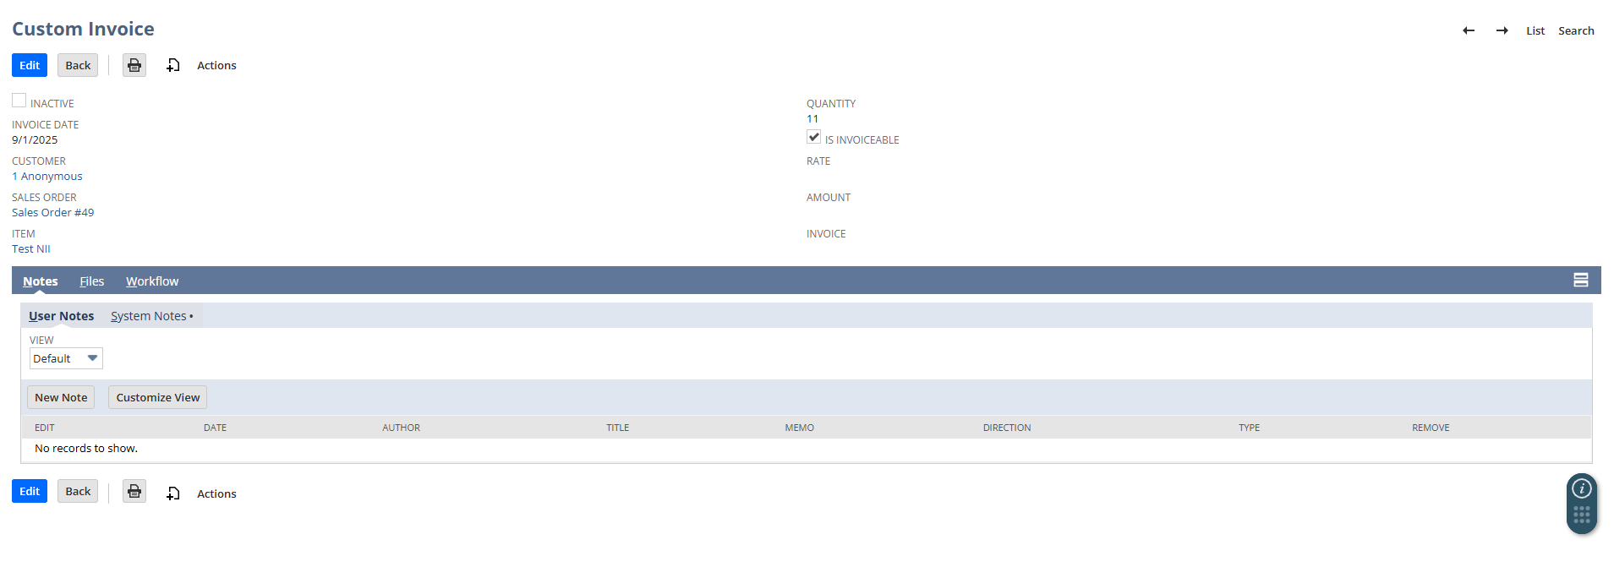
7. Result
7.1 Summary
The Map/Reduce reliably gates invoiceability by item, quantity, and customer, reducing manual checks and preventing invalid bills. The checkbox state on each CIR becomes a clear, auditable signal for downstream processes.

CSS MR createInvoice
1. Executive Summary
This Map/Reduce (MR) SuiteScript 2.1 automates invoice creation from Custom Invoice Records (CIR). It searches invoiceable CIRs without an invoice, groups them by Customer + Sales Order + Invoice Date, transforms the Sales Order → Invoice, and keeps only the item lines present in the group (with correct quantities). Each processed CIR is linked to the created Invoice and marked non-invoiceable to prevent reprocessing.

2. Business Context
Teams needed a reliable way to produce partial invoices from a Sales Order based on pre-approved line/quantity slices captured on a CIR. Manual trimming of invoice lines created errors, rework, and inconsistent billing dates. The MR script removes those manual steps while enforcing grouping rules and data integrity.

3. Solution Overview
- Artifact: Single SuiteScript 2.1 Map/Reduce script.
- Input: Saved Search over CIRs where:
  - custrecord_is_invoiceable = T
  - custrecord_cust_inv_number (Invoice link) is empty
- Grouping Key: customerId || soId || invoiceDate.
- Transform: For each group, record.transform({fromType: SALES_ORDER, toType: INVOICE}).
- Line Filtering: Removes all invoice lines not present in the group; sets line quantities to the requested amounts (safely clamped to available).
- Data Hygiene: Ensures a non-blank amount by forcing Custom price + rate fallback when needed.
- Write-Back: Updates each CIR with the Invoice ID and unchecks “Invoiceable”.

4. Functional Flow
- getInputData: Run one CIR search; return { cirId, soId, customerId, itemId, qty, invDate }.
- map: Emit by grouping key customerId||soId||invDate.
- reduce (per group):
  - Aggregate item quantities requested in the group.
  - Transform SO → Invoice.
  - Delete non-requested lines; set quantities (clamped).
  - Guard rails: if a line’s rate is blank, set price = Custom (-1) and rate = 0.
  - Save Invoice; update all CIRs in the group with invoiceId and set is_invoiceable = F.

5. Script Details
5.1 Configuration (Field IDs used)
- Record: customrecord_invoice_custom
- Fields:
  - Sales Order: custrecord_sales_order
  - Item: custrecord_invoice_item
  - Quantity: custrecord_inv_qty
  - Invoiceable: custrecord_is_invoiceable
  - Invoice Link: custrecord_cust_inv_number
  - Invoice Date: custrecord_inv_date
  - Customer: custrecord_cust_inv_customer

5.2 getInputData()
Filters
- custrecord_is_invoiceable = T
- custrecord_cust_inv_number = empty
Columns Returned
- CIR Id, Sales Order, Item, Quantity, Invoice Date, Customer
Output Shape
- One lightweight object per row: { cirId, soId, customerId, itemId, qty, invDate }

5.3 map()
- Key: customerId||soId||invDate
- Value: original row

5.4 reduce()
- Aggregate requested qty per itemId.
- record.transform(SALES_ORDER → INVOICE) (non-dynamic; performs well for bulk).
- Iterate invoice lines backwards and:
  - Remove lines whose itemId isn’t requested by the group.
- Skip save if no lines remain.
- Save; then submitFields on each CIR to set invoice id and is_invoiceable = F.
- (Optional) Set trandate from group Invoice Date using format.parse.
5.5 Error Handling & Logging
- Defensive logs at group start/end.
- Gracefully skips zero-quantity groups.
- Catches/prints per-group errors without halting the whole MR run.

6. Testing & Validation
Scenarios covered
- Single CIR → one invoice with one line trimmed from SO.
- Multiple CIRs for same Customer/SO/Date → one invoice with merged quantities per item.
- Mixed items (some not requested) → non-requested lines removed.
- Low availability on SO line → quantity clamped; no over-invoicing.
- No remaining lines after filtering → invoice not saved (skip).
UAT Checklist
- Invoice date equals CIR group’s Invoice Date.
- Only group items appear on invoice.
- Quantities match group totals (subject to clamp).
- Each CIR shows created Invoice ID and Invoiceable = F.
- No duplicate invoices for the same group key.

Sales Order-52
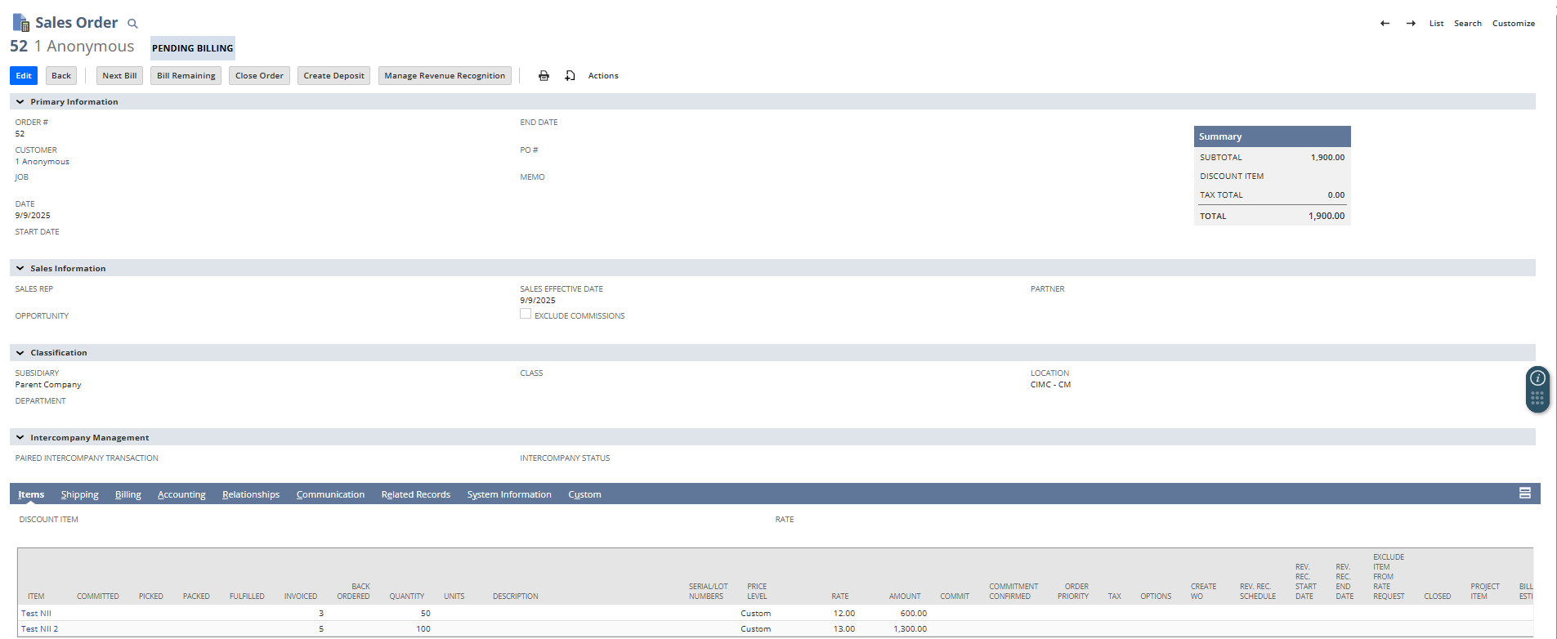

Custom Invoice-16, 17
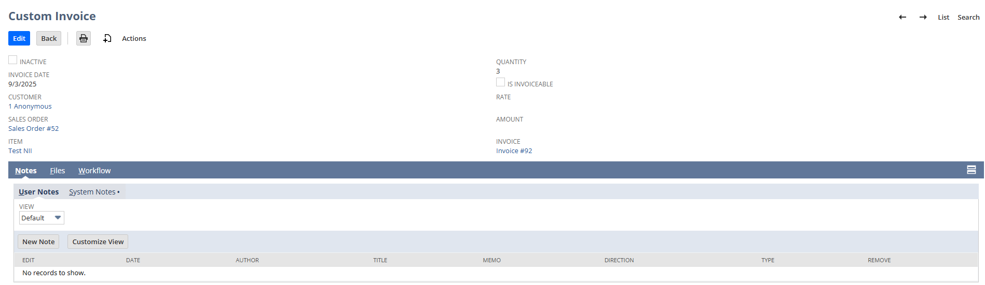
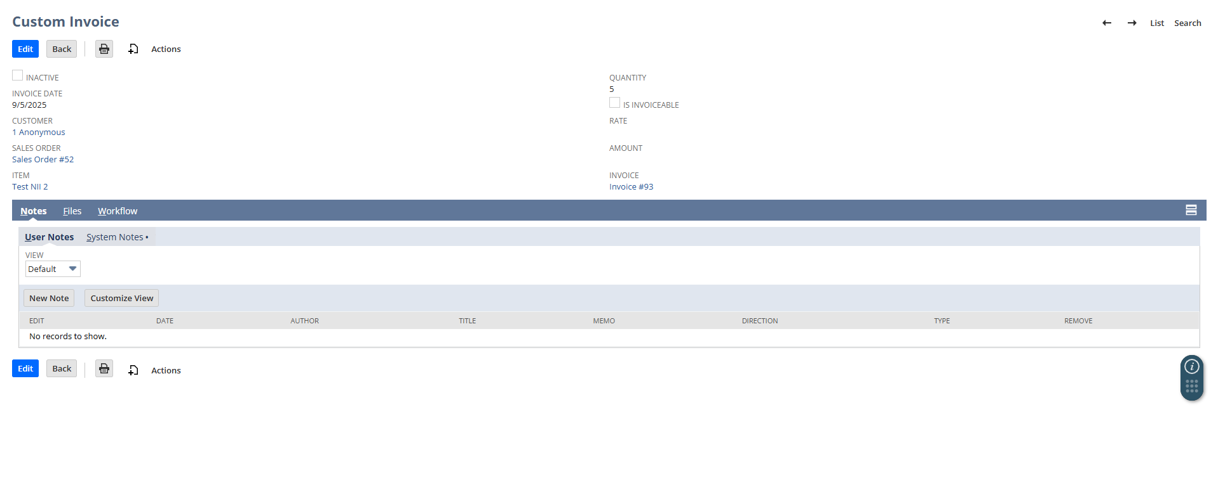

Invoice-92, 93
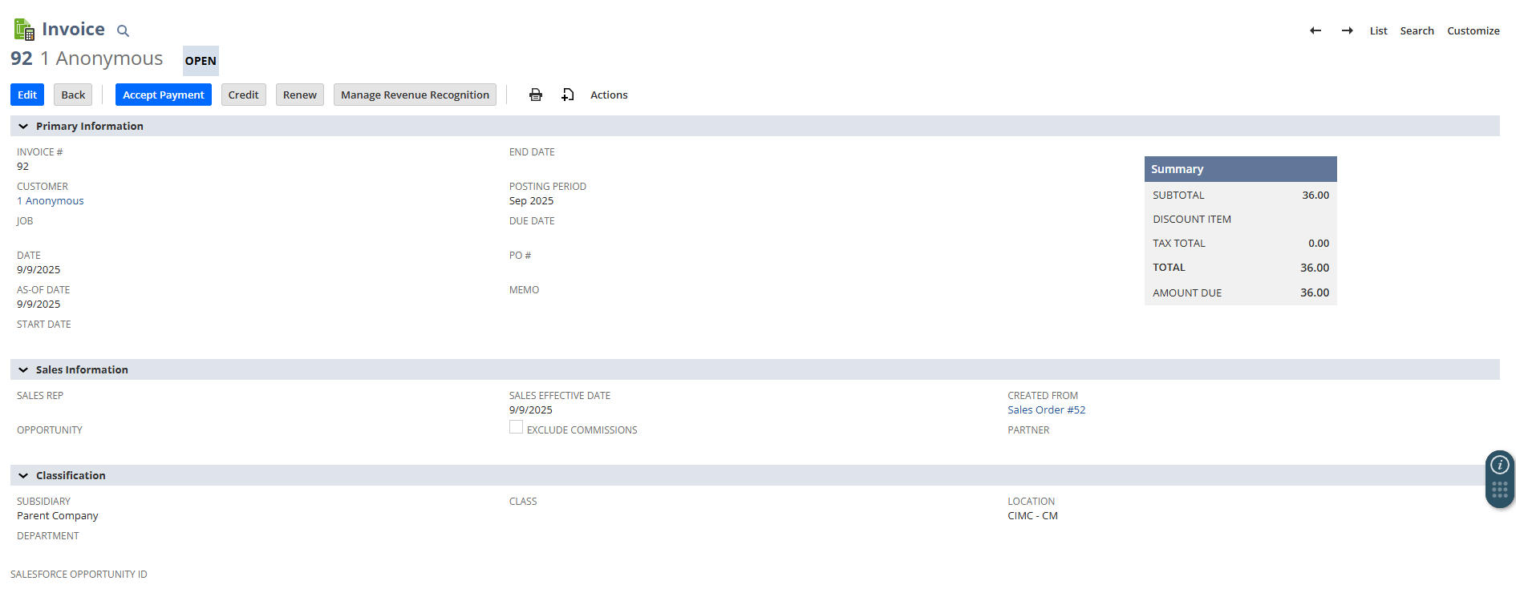

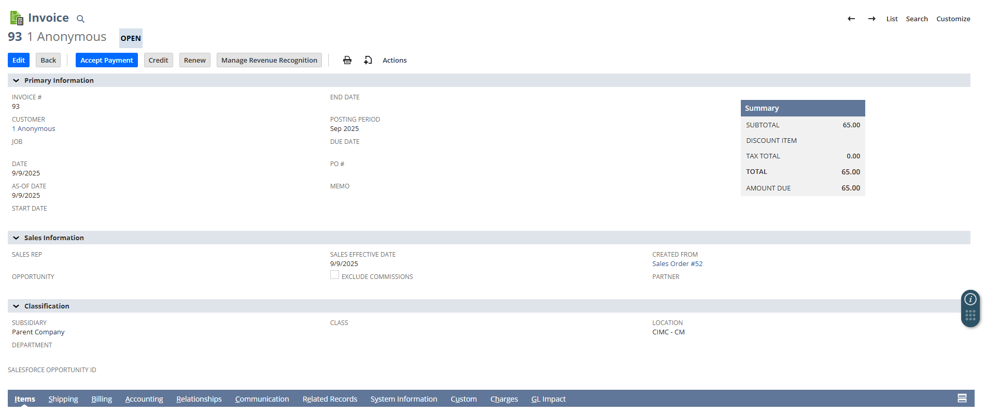

7. Result
Outcome
- Reliable, repeatable partial invoicing driven by CIRs; eliminates manual trimming.
- One invoice per Customer + Sales Order + Invoice Date; lines and quantities strictly match CIR input.
- CIRs are linked and closed for billing to avoid reprocessing.
Operational notes / Next steps
- Add rerun guard (e.g., a batch id) if you expect concurrent runs.
- Consider emailing a summary (groups processed, invoice IDs) post-run.
- Optional: capture remaining (unfulfilled) requested qty in logs for monitoring.

